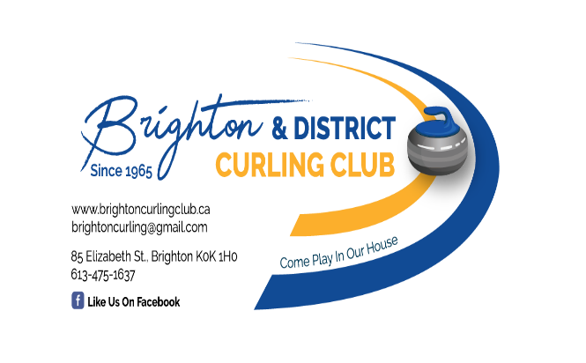

Mailing Address: P.O. Box 636, Brighton, ON K0K 1H0

November 1, 2024
To: Renters of King Edward Community Centre Facilities
RE: BAR SERVICE
The Brighton & District Curling Club is able to provide bar service at the King Edward Community Centre.

- minimum 150 guests
- cost is $ 250 plus payment to servers, all of whom are certified with AGCO as Smart Servers
- server rate is $ 18.00 per hour plus tips
- all bar proceeds are retained by the Brighton & District Curling Club

If you are setting up your own bar, and need certified Smart Servers, we can provide your contact information to our Smart Servers.

For more information, please contact Caroline Watt, Bar and Rental Coordinator at bdccrentals@gmail.com or leave a message at (613) 475 - 1637.

Susan Ruffo
President

